**Lab Task:4**

**Topic: Loops**

Write a c++ program to generate following patterns using loops.

**Note: Your program must be generic i.e it should work on all positive values of n.**

**Part(a):**

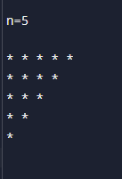

**Part(b):**

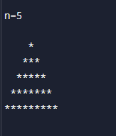

**Part(c):**

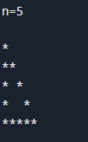

**Part(d):**

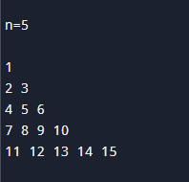

**Part(e):**

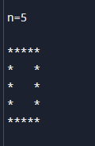

**Submission instructions:**

* Submit single .cpp file containing code for all patterns.
* Rename your file as **i24XXXX_LAB04.cpp** and then submit it on GCR.